AGC Thoughts

PST does not have any AGC or area related models. Previous work on PSLTDSim may be a good starting point for adding AGC to PST. The calculations involved with AGC require knowing an area’s net interchange, scheduled interchange, and frequency.

The NERC defined reported ACE (RACE) calculation is shown below. Ime and Iatec can probably be zeros for simulation purposes leaving only terms dealing with net interchange and frequency (They deal with meter error and area time error correction).



An optional variable frequency bias Bv that replaces the above B is based on absolute frequency deviation as shown below. This may or may not be important to include in a basic AGC model.

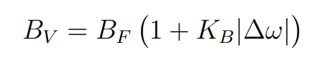

To accommodate AGC, PST would require an ‘area_con’ that lists each bus associated with a particular area. Code will have to be written to calculate and log area interchange based on power flow through lines that connect areas. These values will then be referenced by an AGC model.

A center of area inertia combined frequency (from Sam’s phd work) may be used to best estimate area frequency used in ACE calculations.

An ‘agc_con’ will also have to be created to define the parameters and options associated with AGC such as frequency bias B, action time, filter parameters, optional integration parameters, and gain.

A list of AGC controlled generators with participation factors would also be required. Variable frequency bias options may be included, though not required.

Instead of using the previous ‘array’ based definitions that PST has historically employed for system definitions, a structured array approach may be used i.e.

agc_con(1).actTime = 30; % AGC action time for AGC 1  
….  
agc_con(2).ctrlGens = [2,3,4]; % list of AGC gens for AGC 2  
…  
agc_con(2).genPF = [0.25, 0.25, 0.5]; % participation factor for AGC2  
….  
etc.

The AGC model from PSTLTDSim contains some basic and optional blocks. The conditional summing block contains logic that may be used to collect error values that are deemed internal to an area to more efficiently respond to events. 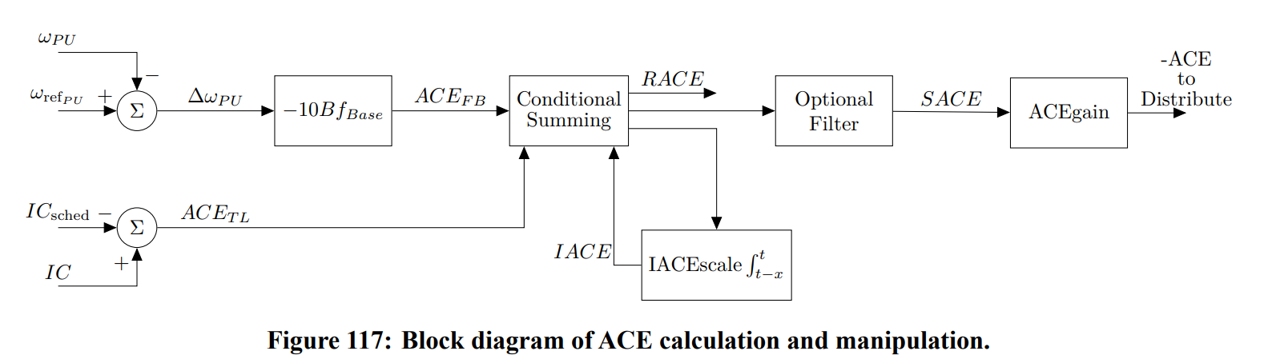

The integration used in the AGC model of PSLTDSim was a window integrator with a user defined time range. This seems possible in PST, though will require some considerations with variable time steps.

In simulations carried out in PSLTDSim, the most useful optional filter was a PI type of block shown below.

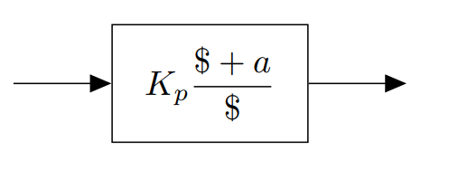

ACE signals distributed to participating generators were set to ramp relative to a generators Pref value, however, a lowpass filter with a large time constant (1/4 action time?) may be an easier implementation for PST.

Specific plant control was not created due to time constraints and may be overly complicated for this project.